Sur l'autoroute
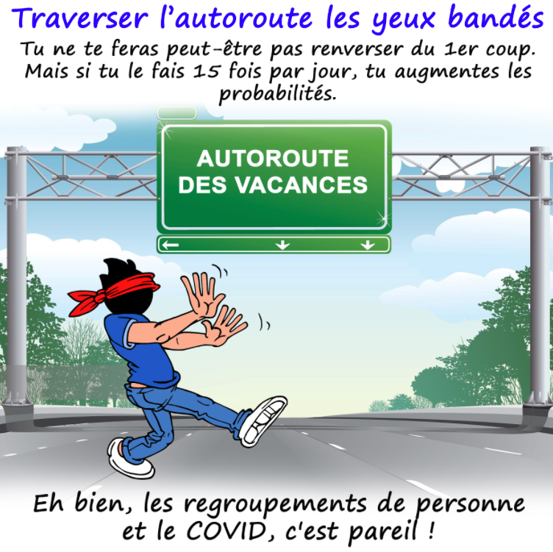
1daf3945ece89a40c50787a1fa8b7471.png}}
5f3e2ff7454596e3b95f38c11dc92e72.png}}
90594c6c612fe2fc04ae257adaa9a79e.png}}
e67377352d56f0219dc1947a4274cfa7.png}}
53660e27bdd2176dafcfcc50229c4925.png}}
78e79a30ae0b728e05cee898b7be9787.png}}

